**ALGORITHMS TO FIND THE SHORTEST SAFE ROUTES TO PREVENT SEXUAL HARASSMENT**

|  |  |  |  |
| --- | --- | --- | --- |
| Luis Alejandro Baena Marín  Universidad Eafit  Colombia  labaenam@eafit.edu.co | Juan Camilo Bermúdez Colorado  Universidad Eafit  Colombia  jcbermudec@eafit.edu.co | Andrea Serna Universidad Eafit Colombia asernac1@eafit.edu.co | Mauricio Toro  Universidad Eafit  Colombia  mtorobe@eafit.edu.co |

# **ABSTRACT**

Many people are concerned about street sexual harassment. This is a very important issue. When there is real danger, we think a lot about if we should go to a given place or if we shouldn't. Because of that, we'll try to develop an algorithm that gives people the most secure and shortest path to go to a given place. This carries lots of difficulties. For example, we must define very well the criteria to consider a certain place “secure”. We must define where we are going to obtain our data to apply these criteria, and how we are going to model the criteria into a path finding. And, of course, how we are going to make a path finding. What is the algorithm you have proposed to solve the problem? What quantitative results have you obtained? What are the conclusions of this work? The abstract should be **at most 200 words**. (*In this semester, you should summarize here the execution times, and the results obtained with the three paths*).

## **Key words**

|  |
| --- |
| Shortest route, street sexual harassment, identification of safe routes, crime prevention |

# **1. INTRODUCTION**

# Sexual harassment is a problem that exists in all countries of the world, many actions are considered sexual harassment, which range from catcalling to rape. The main victims of this problem are women.

# **1.1. The problem**

On the other hand, we all like to spend as little time as possible on transport. Also, People who are new to the city, have no idea about the safe routes. Though people rely on google maps for planning their routes; yet it only provides the shortest path & give no consideration for safety of the path

**1.2 Solution**

Explain, briefly, your solution to the problem *(In this semester, the solution is a pedestrian algorithm to reduce both the distance and the risk of harassment. Which algorithms did you choose? Why?)*

**1.3 Structure of the article**

Next, in Section 2, we present work related to the problem. Then, in Section 3, we present the datasets and methods used in this research. In Section 4, we present the algorithm design. Then, in Section 5, we present the results. Finally, in Section 6, we discuss the results and propose some directions for future work.

**2. RELATED WORK**

## Below, we explain four works related to finding ways to prevent street sexual harassment and crime in general.

## **2.1** **Incorporating a Safety Index into Pathfinding**

## It considers both traffic safety, defined as "the ratio of the rate of deceleration to avoid a crash to the maximum rate of deceleration available", and travel time. They managed to develop the methodology for the index by using roadside crash mechanisms but struggled with limitations such as not all crash types being considered. Other conditions such as vehicle type and pavement were considered. They applied it to the shortest path search algorithm. A review of it based on the findings of previous articles considered it to be a good enough approximation for road safety.

## **2.2 Preventing Sexual Harassment Through a Path**

## Bresenham’s line algorithm is a line drawing algorithm that determines the points of an n-dimensional raster that should be selected in order to form a close approximation to a straight line between two points.

## The general idea behind this algorithm is: given a starting endpoint of a line segment, the next grid point it traverses to get to the other endpoint is determined by evaluating where the line segment crosses relative to the midpoint (above or below) of the two possible grid points choices.

## Zooming back out to our problem at hand here, we apply these grid coverage methods to compute the average of risk scores of steps for each route to determine the best.

## **2.3 Route-The Safe: A Robust Model for Safest Route Prediction Using Crime and Accidental Data**

## The algorithm works this way: first the user enters the destination location. If there is only one route, that is the one we show to the user. On the other hand, if there is more than one route, we choose the safest route using the Knn regression model, and if there are several routes with the same score, the one with the shortest distance is chosen. That is the one that is shown to the user.

## KNN regression is a non-parametric method that, in an intuitive manner, approximates the association between independent variables and the continuous outcome by averaging the observations in the same neighborhood.

The model suggests the safest route by selecting the route which has the lowest risk score. If more than one route has the lowest risk score it suggest the route which has the shortest distance.

## **2.4** **Safety-aware routing for motorised tourists based on open data and VGI**

## In this article is also developed a safety index based on volunteered geographic information and governmental data, specially from police stations nearby. The primary data taken in account was of course crime data. They used it in LA and calculated the least dangerous path and the shortest one. The algorithm they used to find the paths with and without the index was the OPTICS algorithm. The algorithm orders points from the path as if they were linear. Then saves a relative distance for each point and calculates the density-based clusters in spatial data.

## **3. MATERIALS AND METHODS**

In this section, we explain how the data were collected and processed, and then different alternative path algorithms that reduce both the distance and the risk of sexual street harassment.

## **3.1 Data collection and processing**

The map of Medellín was obtained from *Open Street Maps* (OSM)[1]  and downloaded using the Python API[2] OSMnx. The map includes (1) the length of each segment, in meters; (2) the indication of whether the segment is one-way or not, and (3) the known binary representations of the geometries obtained from the metadata provided by OSM.

For this project, a linear combination (LC) was calculated that captures the maximum variance between (i) the fraction of households that feel insecure and (ii) the fraction of households with incomes below one minimum wage. These data were obtained from the 2017 Medellín quality of life survey. The CL was normalized, using the maximum and minimum, to obtain values between 0 and 1. The CL was obtained using principal components analysis. The risk of harassment is defined as one minus the normalized CL. Figure 1 presents the calculated risk of bullying. The map is available on GitHub[3] .

**Figure 1.** Risk of sexual harassment calculated as a linear combination of the fraction of households that feel unsafe and the fraction of households with income below one minimum wage, obtained from the 2017 Medellín Quality of Life Survey.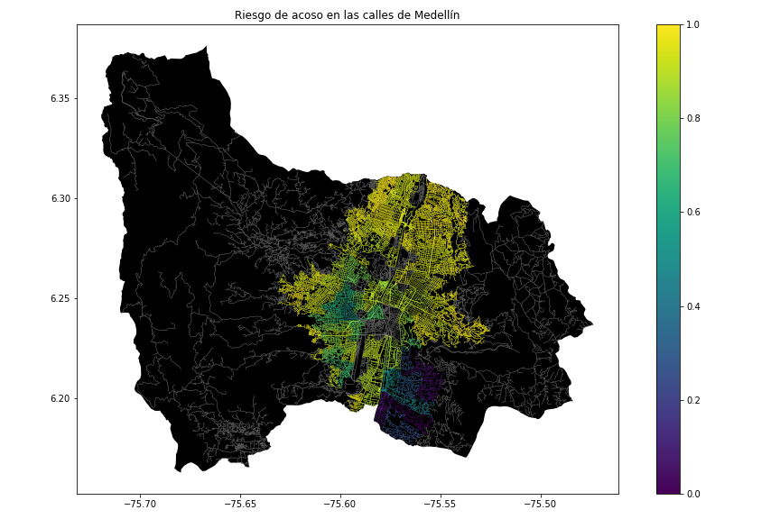

## **3.2 Algorithmic alternatives that reduce the risk of sexual street harassment and distance**

## In the following, we present different algorithms used for a path that reduces both street sexual harassment and distance. *(In this semester, examples of such algorithms are DFS, BFS, Dijkstra, A*, Bellman, Floyd, among others).*

**3.2.1 Find the shortest path in a maze**

It explores all four possible paths and recursively validates if they lead to the destination, starting from the given cell. Then updates the minimum path length each time it reaches the destination cell. It backtracks when a path doesn’t reach its destination or has explored all possible paths from the cell. Its time complexity will be high because all paths are traveled.

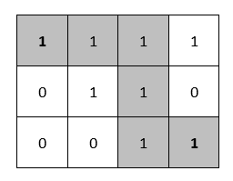

**3.2.2 Shortest Path in Maze using Backtracking**

This algorithm also uses backtracking to explore all possibilities. It simply checks whether a move is valid or not. If it is valid, it keeps moving until stuck, otherwise backtrack to the former cell and explore other possible moves to the destination.

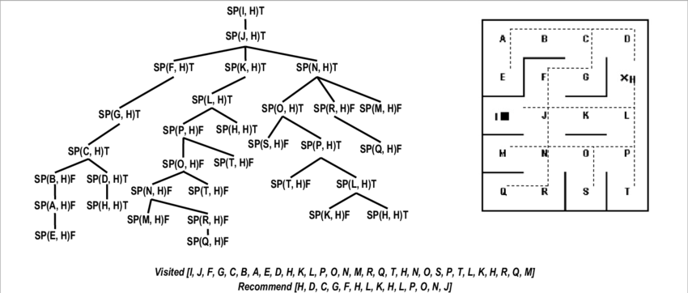

**3.2.3 Shortest path in a maze – Lee Algorithm**

The Lee algorithm is one possible solution for maze routing problems based on Breadth–first search. It always gives an optimal solution, if one exists, but is slow and requires considerable memory. Following is the complete algorithm: Create an empty queue and enqueue the source cell having a distance 0 from the source (itself) and mark it as visited. The Loop till queue is empty. Dequeue the front node. If the popped node is the destination node, then return its distance. Otherwise, for each of four adjacent cells of the current cell, enqueue each valid cell with +1 distance and mark them as visited. And if all the queue nodes are processed, and the destination is not reached, then return false.

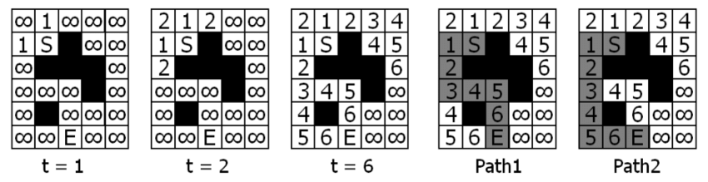

**3.2.4 Pulse algorithm**

## Pulse algorithm consists of two phases:

## (1) A bounding phase to compute a lower bound cost of every node with given consumed resources.

## (2) A recursive exploration phase based on an implicit enumeration of the solution space to find the optimal solution. The bounding phase is also based on the recursive exploration.

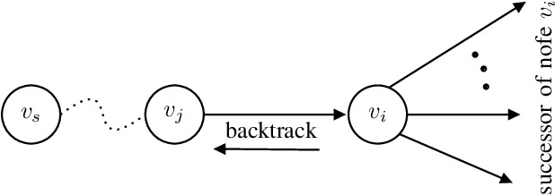

## **4. ALGORITHM DESIGN AND IMPLEMENTATION**

## In the following, we explain the data structures and algorithms used in this work. The implementations of the data structures and algorithms are available on Github[4] .

## **4.1 Data Structures**

## Explain the data structure that was used to represent the map of the city of Medellín. Make a figure that explains it. Do not use figures from the Internet. *(In this semester, examples of data structures are adjacency matrix, adjacency list, adjacency list using a dictionary).* The data structure is presented in Figure 2.

**Figure 2:** An example street map is presented in (a) and its representation as an adjacency list in (b). (*Please feel free to change this graph if you use a different data structure*).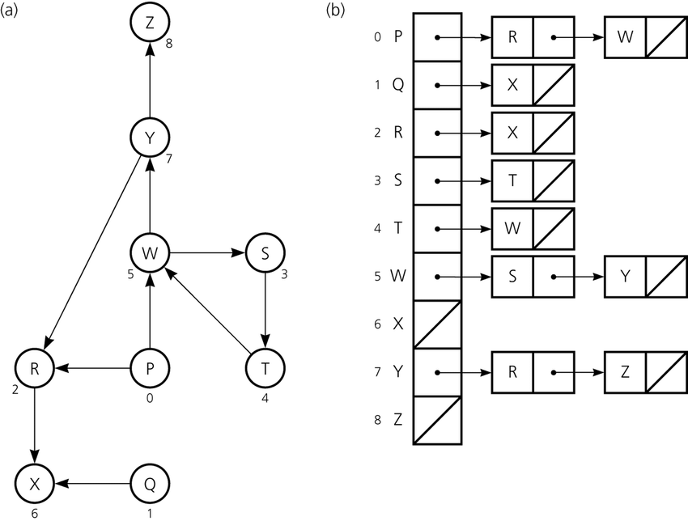

**4.2 Algorithms**

In this paper, we propose an algorithm for a path that minimizes both the distance and the risk of street sexual harassment.

**4.2.1 Algorithm for a pedestrian path that reduces both distance and risk of sexual street harassment**

Explain the design of the algorithm for calculating a path that reduces both distance and risk of harassment and make your own graph. Do not use graphs from the Internet, make your own. *(In this semester, the algorithm could be DFS, BFS, Dijkstra, A*, Bellman, Floyd among others ).* The algorithm is exemplified in Figure 3.

**Figure 3:** Calculation of a path that reduces both distance and risk of harassment (please feel free to change this figure if you use a different algorithm).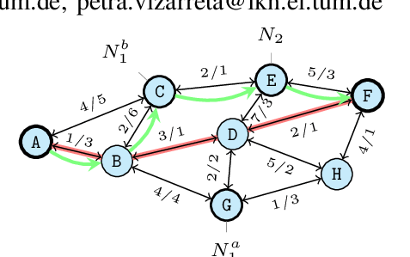

**4.2.2 Calculation of two other paths to reduce both the distance and the risk of sexual street harassment**

Explain the other two paths that reduce both distance and risk of street sexual harassment and make your own graph. Do not use graphs from the Internet, make your own. *(In this semester, the algorithm could be DFS, BFS, Dijkstra, A*, among others).* ) The algorithm is exemplified in Figure 4.

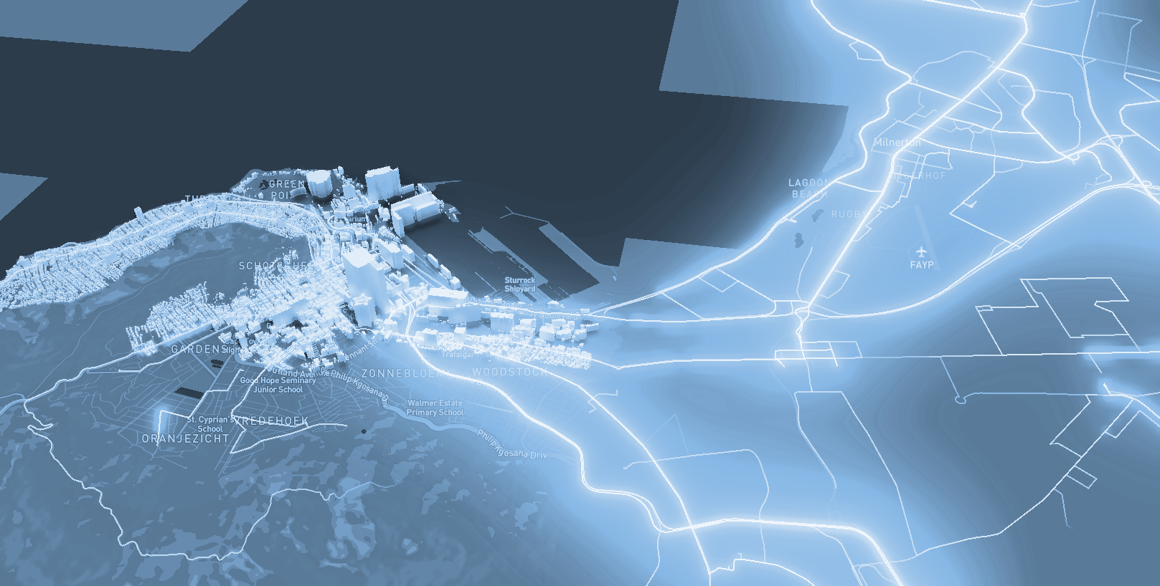

**Figure 4:** Map of the city of Medellín showing three pedestrian paths that reduce both the risk of sexual harassment and the distance in meters between the EAFIT University and the National University.

**4.3 Algorithm complexity analysis**

Explain, in your own words, the analysis, for the worst case, using the notation O. How did you calculate these complexities? Explain briefly.

|  |  |
| --- | --- |
| **Algorithm** | **Time complexity** |
| Algorithm name | O(V2 *E2 ) |
| Name of the second algorithm (in case you have tried two) | O(E3 *V*2V ) |

**Table 1:** Time complexity of the name of your algorithm, where V is.... E is... *(Please explain what V and E mean in this problem). No, do not use 'n'.*

|  |  |
| --- | --- |
| **Data Structure** | **Complexity of memory** |
| Name of the data structure | O(V*E*2E  ) |
| Name of the second data structure (in case you have tried two) | O(2E* 2V ) |

**Table 2:** Memory complexity of the data structure name used by your algorithm, where V is.... E is... *(Please explain what V and E mean in this problem). No, don't use 'n'. That is, don't use 'n'. Not 'n'.*

**4.4 Algorithm design criteria**

Explain why the algorithm was designed that way. Use objective criteria. Objective criteria are based on efficiency, which is measured in terms of time and memory. Examples of NON-objective criteria are: "I was sick", "it was the first data structure I found on the Internet", "I did it the last day before the deadline", "it's easier", etc. Remember: This is 40% of the project grade.

**5. RESULTS**

In this section, we present some quantitative results on the three pathways that reduce both the distance and the risk of sexual street harassment.

**5.1 Results of the paths that reduces both distance and risk of sexual street harassment**

Next, we present the results obtained from *three paths that reduce both distance and harassment,* in Table 3.

|  |  |  |  |
| --- | --- | --- | --- |
| **Origin** | **Destination** | **Distance** | **Risk** |
| Eafit | Unal | ?? | ?? |
| Eafit | Unal | ??? | ?? |
| Eafit | Unal | ?? | ?? |

Distance in meters and risk of sexual street harassment (between 0 and 1) to walk from EAFIT University to the National University.

**5.2 Algorithm execution times**

In Table 4, we explain the ratio of the average execution times of the queries presented in Table 3.

Calculate the execution time for the queries presented in Table 3.

## 

|  |  |
| --- | --- |
| **Calculation of v** | **Average run times (s)** |
| v = ?? | 100000.2 s |
| v = ?? | 800000.1 s |
| v = ?? | 8450000 s |

## **Table 4:** *Algorithm* name execution times *(Please write the name of the algorithm, e.g. DFS, BFS, A*)* for each of the three calculator paths between EAFIT and Universidad Nacional.

## **6. CONCLUSIONS**

Explain the results obtained. Are the paths significantly different? How useful is this for the city? Are the runtimes reasonable to use this implementation in a real situation? Which path would you recommend for a mobile or web application?

**6.1 Future work**

Answer, what would you like to improve in the future? How would you like to improve your algorithm and its application? Will you continue this project working on optimization? Statistics? Web development? Machine learning? Virtual reality? How?

# **ACKNOWLEDGEMENTS**

Identify the type of thank you you wish to write: to a person or to an institution. Keep the following guidelines in mind: 1. The professor's name is not mentioned because he or she is an author. 2. You should not mention the authors of articles that you have not contacted. 3. You should mention students, teachers of other courses who have helped you.

By way of example: This research has been supported/partially supported by [Name of Foundation, Donor].

We are grateful for help with [particular technique, methodology] to [First name Last name, position, name of institution] for comments that greatly improved this manuscript.

The authors thank Professor Juan Carlos Duque, Universidad EAFIT, for providing the data from the 2017 Medellín Quality of Life Survey, processed in a *Shapefile*.

# **REFERENCES**

1. He, Z. and Qin, X., 2016, Incorporating a Safety Index into Pathfinding, Transportation, Research Record 2659. 343-364.
2. Ma, D., 2020, Preventing Sexual Harassment Through a Path Finding Algorithm Using Nearby Search, Omdena.
3. Gauri, V. and Sandeep, C., 2019, Route-The Safe: A Robust Model for Safest Route Prediction Using Crime and Accidental Data, ResearchGate.
4. Keler, A. and Damascene, J., 2016, Safety-aware routing for motorised tourists based on open data and VGI, ResearchGate.
5. Techie Delight, 2022, Find the shortest path in a maze, Techie Delight.
6. Techie Delight, 2022, Shortest path in a maze – Lee Algorithm, Techie Delight.
7. Pencil Programmer, 2022, Shortest Path in Maze using Backtracking, Pencil Programmer.
8. Li, J. and Han, X., 2019, Revised Pulse Algorithm for Elementary Shortest Path Problem with Resource Constraints, Seventh International Symposium on Computing and Networking.

1. <https://www.openstreetmap.org/>
2. https://osmnx.readthedocs.io/
3. https://github.com/mauriciotoro/ST0245Eafit/tree/master/proyecto/Datasets
4. http://www.github.com/ ????????? /.../project/